ANSI SQL Using MySQL
Exercises(1-25)
- User Upcoming Events
Show a list of all upcoming events a user is registered for in their city, sorted by date.
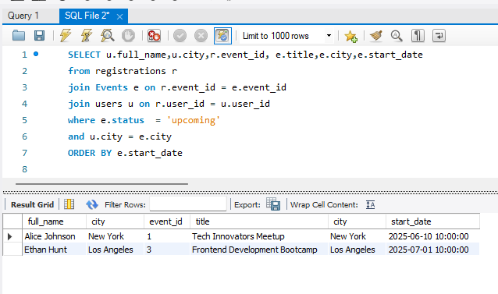

- Top Rated Events
Identify events with the highest average rating, considering only those that have received at
least 10 feedback submissions.

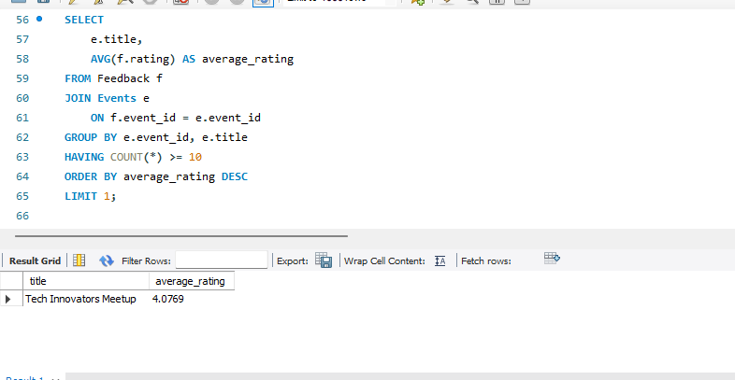
- Inactive Users
Retrieve users who have not registered for any events in the last 90 days.

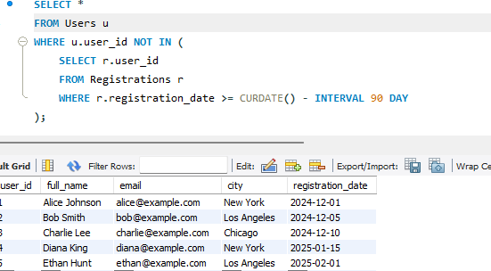
- Peak Session Hours
Count how many sessions are scheduled between 10 AM to 12 PM for each event.

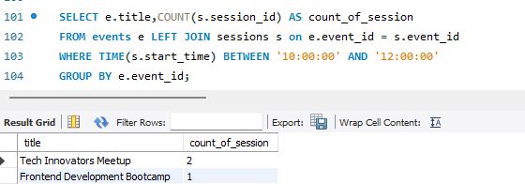

- Most Active Cities
List the top 5 cities with the highest number of distinct user registrations.
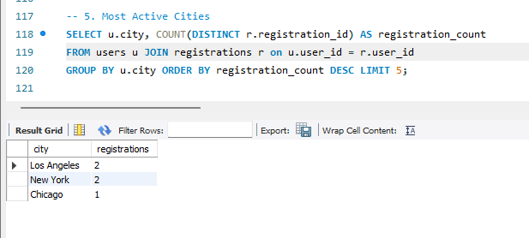
- Event Resource Summary
Generate a report showing the number of resources (PDFs, images, links) uploaded for each event

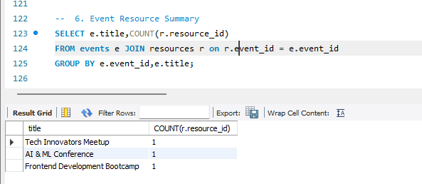

- Low Feedback Alerts
List all users who gave feedback with a rating less than 3, along with their comments and associated event names
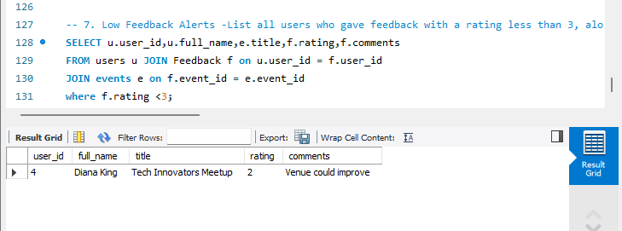
- Sessions per Upcoming Event
Display all upcoming events with the count of sessions scheduled for them.

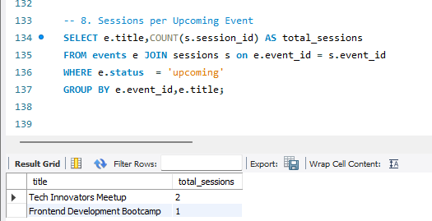
- Organizer Event Summary
For each event organizer, show the number of events created and their current status (upcoming, completed, cancelled).
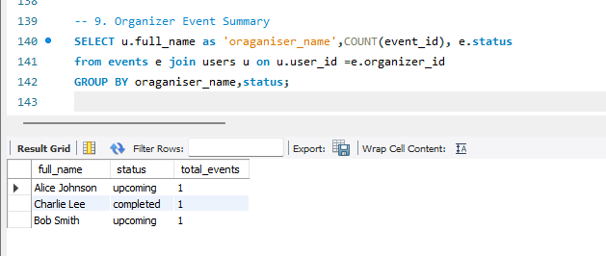
- Feedback Gap
Identify events that had registrations but received no feedback at all

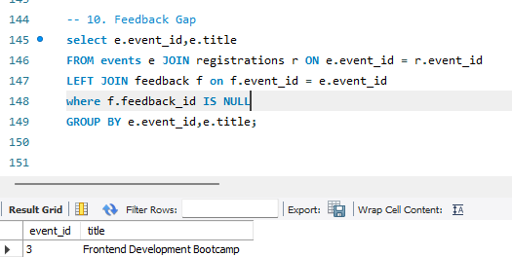

- Daily New User Count
Find the number of users who registered each day in the last 7 days
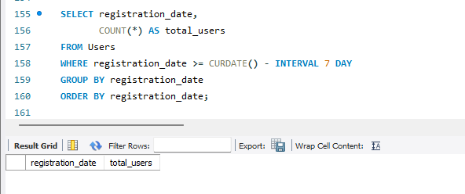
- Event with Maximum Sessions
List the event(s) with the highest number of sessions
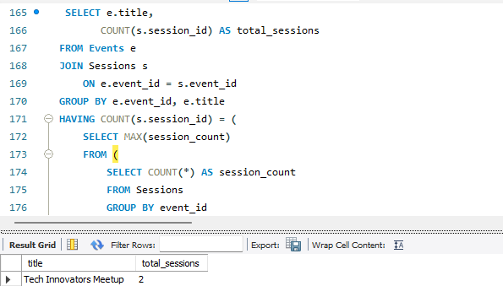

- Average Rating per City
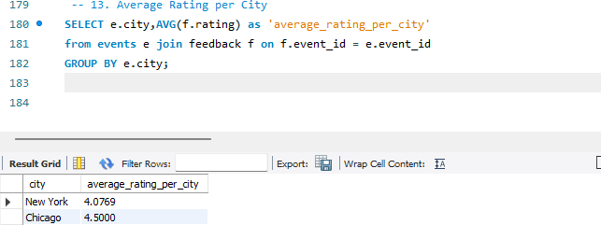
Calculate the average feedback rating of events conducted in each city

- Most Registered Events
List top 3 events based on the total number of user registrations

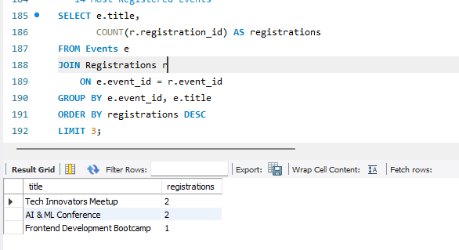

- Event Session Time Conflict
Identify overlapping sessions within the same event (i.e., session start and end times that conflict)
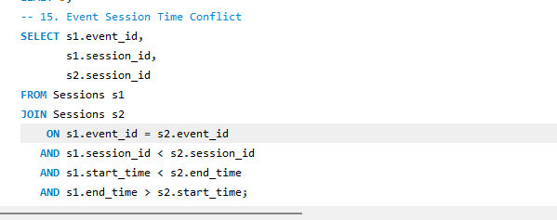
- Unregistered Active Users
Find users who created an account in the last 30 days but havenʼt registered for any events.

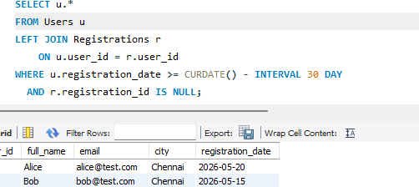

- Multi-Session Speakers
Identify speakers who are handling more than one session across all events.
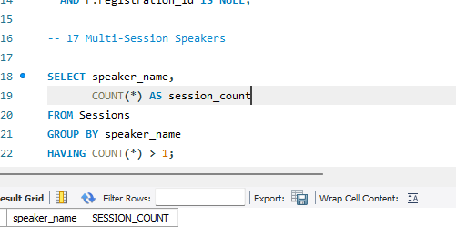

- Resource Availability Check
List all events that do not have any resources uploaded.

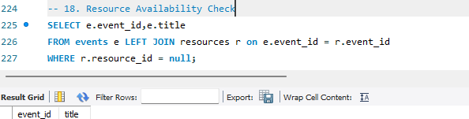

- Completed Events with Feedback Summary
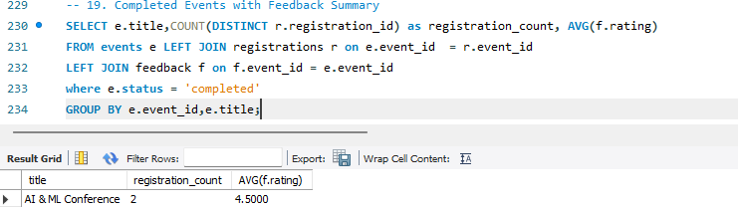
For completed events, show total registrations and average feedback rating.

- User Engagement Index
For each user, calculate how many events they attended and how many feedbacks they submitted

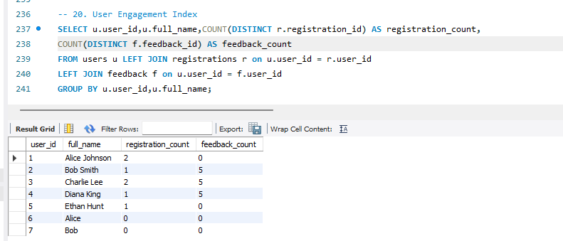

- Top Feedback Providers
List top 5 users who have submitted the most feedback entries.

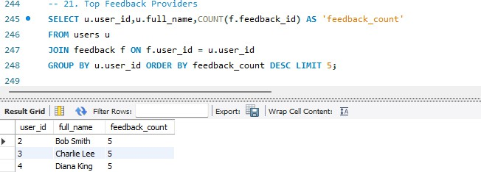

- Duplicate Registrations Check
Detect if a user has been registered more than once for the same event.

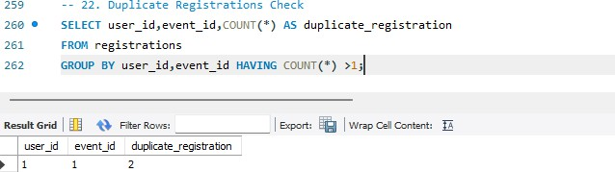

- Registration Trends
Show a month-wise registration count trend over the past 12 months.

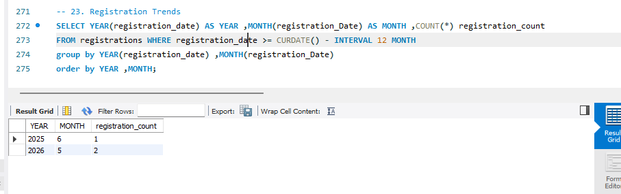

- Average Session Duration per Event
Compute the average duration (in minutes) of sessions in each event.

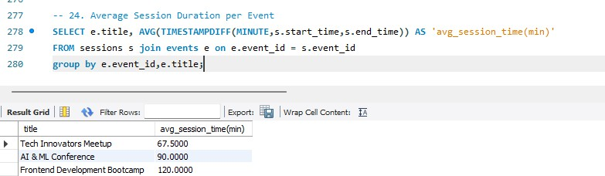

- Events Without Sessions
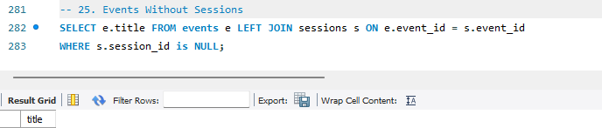
List all events that currently have no sessions scheduled under them

